Total Marks 77/92

1. Name these compounds.

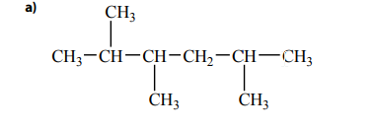

2,3,5-trymethylhexane 2/2

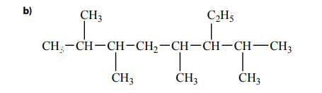

3-ethyl-2,4,6,7-tetramethyloctane 2/2

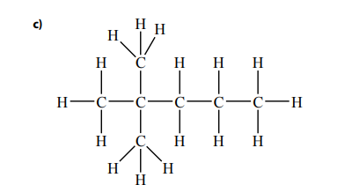

2,2-dimethylpentane 2/2

1. Draw a structural formula for each of the following
   1. 3-ethyl-3-methylhexane 2/2  
      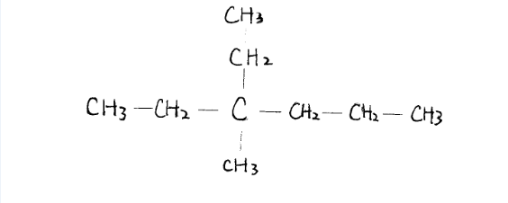
   2. 1-ethyl-3-propolcyclohexane 2/2

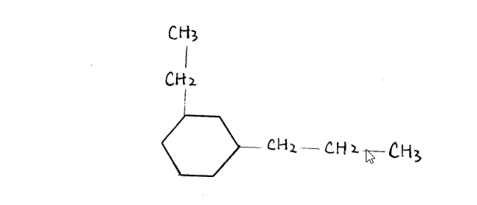

* 1. 2,4-dimethylheptane 2/2  
     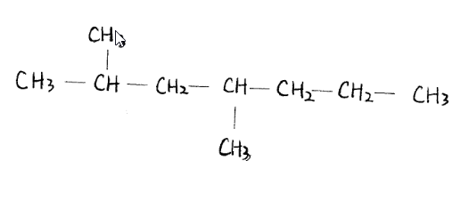

1. A saturated long-chain hydrocarbon undergoes complete combustion. Analysis of the reaction products reveals that 7 molecules of carbon dioxide and 9 molecules of water vapour are produced for every molecule of the hydrocarbon that burns. Write a balanced chemical equation for this reaction $$_____C_{a}H_{b}+{_____O}_{2}→7CO_{2}+9H_{2}O$$

$$a=7, b=2*9=18$$

$$C_{7}H_{18}+\frac{23}{2}O_{2}→ 7CO_{2}+9H_{2}O$$

$${2C}_{7}H_{18}+O_{2}→ 14CO_{2}+18H_{2}O$$

$$C_{7}H_{18}+{11O}_{2}→ 7CO_{2}+8 H_{2}O$$

1/3

1. Consider the following data and then answer the questions that follow  
     
   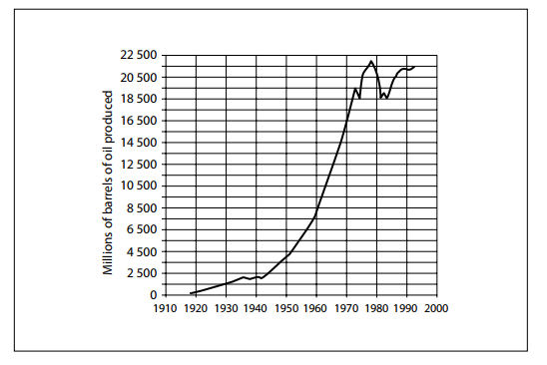
   1. Suggest one possible reason for the general trend indicated on the graph between 1910 and 2000

In the 20th century, the advance of industry and technologies and increased the demand of oil to use in manufacturing and energy. Therefore, the production of oil experienced exponential increase in the last century automobiles specifically were on the rise. 1.5/2

* 1. In your opinion, is this trend sustainable? Why or why not?

Oil is formed when organisms die and become buried by sediments, and underwent chemical process that took millions of years. According the current usage rate of oil, we are consuming oil much faster than it is being formed. Therefore, the current is not sustainable 2/2

* 1. Suggest a plan of action that your household could initiate to help reverse the trend  
     Reduce the use of oil and oil-related products:
     1. Take public transit instead of driving. ✓
     2. use less plastic and other oil-made products. ✓
     3. Rely on manual labor when possible and decrease the amount of power used.✓3/3

1. Draw the structural formula for these compounds.
   1. Ethylcyclopentene it is a pentene therefore it will have a double bond 1/2  
        
      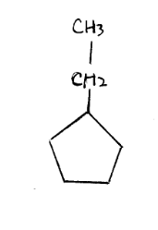
   2. 5-ethyl-2,2-dimethyl-3-heptene 2/2  
      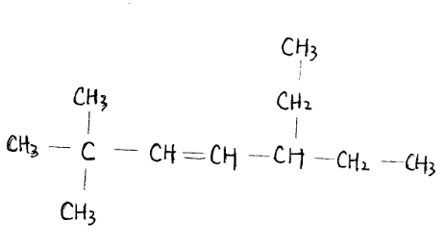
   3. 3,4-dimethylhexyne 2/2  
      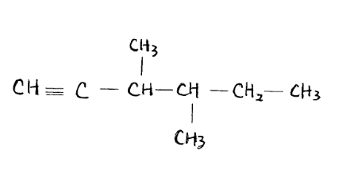
2. Name the following compounds

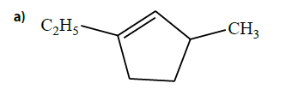

1-ethyl-3-methylcyclopentene 2/2

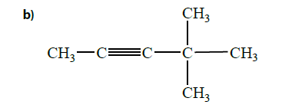

2,2-dimethyl-3-pentyne 4,4-dimethyl-2-pentyne the triple bond will have the priority in the numbering of the carbons 1/2

1. Two unlabeled bottles containing clear, colorless liquids are found in the organic section of the chemical storage room. Describe the chemical test that could be conducted in order to determine whether the two substances are unsaturated or saturated.  
     
   Add pure elemental molecules (not hydrogen) to the liquids and observe for the presence of chemical reactions. In order for chemical reactions to occur with hydrocarbons, a catalyst is required to provide additional energy. Since there is no catalyst present, a saturate hydrocarbon should not undergo any chemical reaction, and the chemicals should not mix. On the other hand, unsaturated hydrocarbons do not require such catalyst, and would mix easily with the added molecules. you would need to do a colour reaction addition test such as bromine or iodine 1/2
2. Write a chemical equation for addition reactions to produce 3-methyl-3-hexanol. Condensed structural formulas should be used for each organic compound.

Molecular formula of 3-methyl-3-hexanol: C7H16O

Reaction:

$C_{7}H_{14}+H_{2}O→C_{7}H_{16}O$ 0.5/3 structural formulas not chemical formulas should be used

1. 1. Trichloroethylene, C2HCl3, which you read about in the introduction, is denser than water. Most organic liquids, such as oil, are less dense than water. Why is it easier to clean up an oil spill in a lake than it is to clean up a spill of TCE?

Because oil is lighter than water, an oil spill leave oil floating on top of water. TCE is heavier denser which is different than mass than water and will sink below when spilled. Therefore, cleaning up oil is easier than cleaning up TCE 0.5/1

* 1. Research the health effects of exposure to TCE. Based on your research, is the ban on this substance justified? Why or why not?

The ban on TCE is justified. Chronic exposure to TCE can cause many irreversible damage to one’s health. Short term symptoms can include nausea, headaches, vomiting, etc, but the real danger comes from the long-term effects. TCE has been known to be the cause of birth defects, fetal deaths, and other reproductive related effects. In addition, TCE also contributes to many carcinogenic diseases such as cancer in the liver, kidney, and prostates. Base on the extremely dangerous effect that TCE can cause, the ban can be justified,. 3/3

1. Name the following compounds

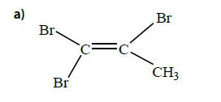

1,2,2-tribromo-methylethane 1,1,2-tribromopropene 0/2

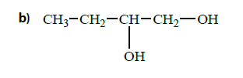

1,3-butadiol 1,2- butandiol 1/2

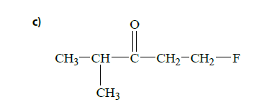

1-Floro-4-methylpentanone 1-fluoro-4-methyl-3- pentanone 1/2

1. Draw the structural formula for the following compounds
   1. 4,4-dichloropentanal✓

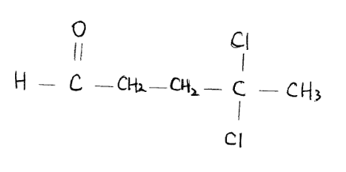

* 1. 2-methylbutanol✓

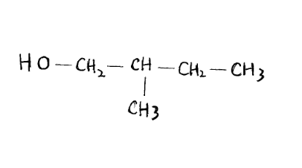

* 1. 3,3-dichlorohexane✓6/6  
       
     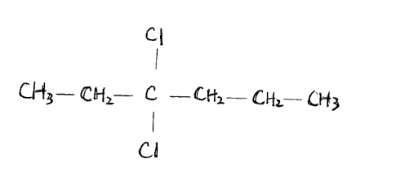

1. Draw and name all of the structural isomers that are ketones with five carbon atoms in its longest chain and the molecular formula C5H10O. Can this molecular formula also have an aldehyde structure? If so, illustrate and name the aldehyde. Can this be drawn as an ether? Explain.

|  |  |
| --- | --- |
| 2-pentanone |  |
| 3-pentanone |  |
| Pentanal |  |
| 2-methylpentanal |  |
| 3-methylpentanal |  |

structural isomers you cannot change the carbon chain therefore only your first two aldehydes are structural isomers.

This formula cannot be drawn as an ether. To be drawn as an ether, there must be 12 H atoms, or 4 C atoms. There is not enough bonds to connect all of the molecule. ✓ 5.5/6

1. Write chemical equations for the synthesis of 2-pentanol from an alkene. Use structural formulas for each organic compound. 3/3

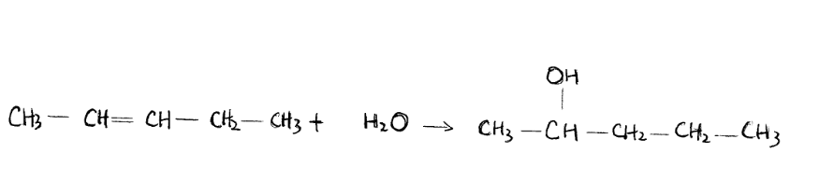

1. The compounds 1-propanol and propanone have approximately the same molar mass. Based on differences in their intermolecular forces, rank these compounds in order to increasing boiling point. Justify your prediction.

1-propanol would have a relatively high boiling point, due to the presence of very strong hydrogen boding between OH and its adjacent molecule✓. In comparison, propanone would have a lower boiling point, despite having the same mass. This is because of the presence of double bonding between C and O. Such bonding would be a dipole-dipole bonding, a type of bonding that is much weaker than hydrogen bonding. ✓3/3

Ranking: higher boiling point – 1-propanol

Lower boiling point – propanone

1. Name the following compounds.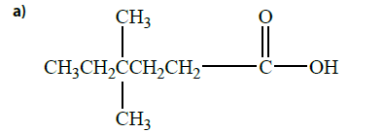

4,4-dimethylpentanoic acid 2/2

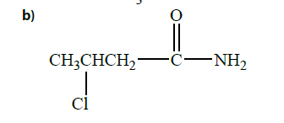

3-chlorobutanamide 2/2

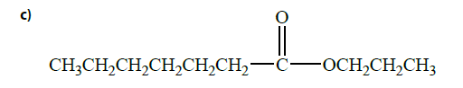

Propyl heptanoate 2/2

1. Write a chemical equation for the synthesis of ethyl 2-methylpropanoate. Use structural formulas for each organic compound in your equation. Name each reactant. 6/6

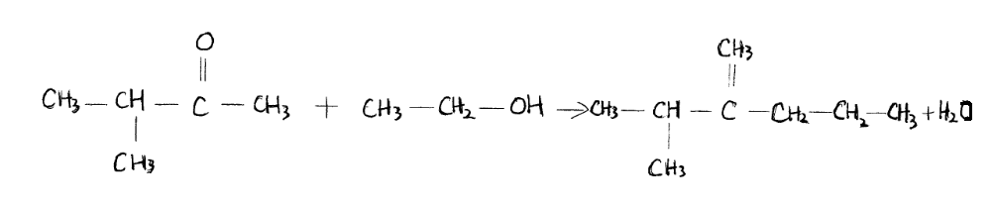

1. 1. Complete the table below by identifying the types of intermolecular forces in each of the following three-carbon compounds. Note: It is possible for there to be more than one type of intermolecular force present in a given compound.

|  |  |  |
| --- | --- | --- |
| Compound | Boiling point | Types of Intermolecular Forces |
| CH3CH2CH3 | -59 | London✓ |
|  | 56 | Dipole-dipole  London✓ |
| CH3CH2CH2OH | 87 | Hydrogen bonding  London✓ 3/3 |

* 1. Account for the boiling points by referring to the intermolecular forces.

London force is the weakest of all the intermolecular forces, and can be overcome with relatively low energy. Therefore, the compounds that are bonded by London force has the lowest boiling point. ✓

Dipole-dipole attraction is stronger than London force, and therefore has a higher boiling point.✓

Hydrogen bonding requires the most energy to be overcame. Compounds with hydrogen bonds usually have very high boiling points✓2/2

1. Many offices and school have already banned the sale of bottled water within their premises. As an expert in environmental chemistry, you have been hired by the Ministry of the Environment to do research and provide advice on the following issue.

Issue: What impact would a total ban on water sold in plastic bottles have on Ontario consumers and on Ontario’s environment?

Research:

Include the following factors in your research and decision making:

The relative success of plastic recycling

The time and energy required for recycling

The safety of bottle water

The cost of bottle water

The amount of plastic water bottles in landfills

The safety of municipal drinking water

Decision:

Make a recommendation on the issue. Provide supporting arguments for your decision. Provide references for your research.

Communicate and summarize your decision:

Write an answer of one to two paragraphs that clearly outlines your decision and provides factual evidence for why it was made.

After collecting facts and researching the pros and cons of using bottled water, the decision has been made to ban all plastic water bottles and its production. ✓There are multiple reasons for this decision. Firstly, Bottled water leads to water shortage. Manufacturing water bottles require huge amounts of water. It takes three to five liters of water to produce every one-liter plastic bottle(Canadians.org).✓The demand for bottled- water is also contributing to the water crisis many regions are currently experiencing. Additionally, the manufacturing and transportation of bottled water require a huge amount of fossil fuel and emit large amounts of greenhouse gas emission, which contributes to the already changing climate. ✓The waste produced by plastic bottles is an also a contributing factor to the destruction of the environment. Only as much as 50% of the plastic bottles are recycled. ✓The remaining usually end up in landfills, which in Ontario, cannot make use of all the bottles left. Lastly, bottled-water is not up to safety standards as municipal drinking water, despite the promising advertisements claiming bottled-water is safe the tap water.✓ In Ontario, water-bottling plants are inspected once three years, while municipal water reservoirs are inspected multiple times-both during and after treatment. As such, it is reasonable to believe banning plastic water bottle, and its production will be beneficial to our provinces environment, natural resource reserve, and the health of our citizens.✓

opinion is clearly stated 1/1

supporting facts 5/6 (cost comparison is missing)

references 1/2

APA format should be used for all references not just urls

Other sources of information?

References:

https://canadians.org/sites/default/files/publications/5%20reasons%20to%20ban%20bottled%20water.pdf